
Developing a model of the atom: radioactive atoms
At this stage, pupils may regard atoms as the fundamental chemical particles. True, electrons can be chipped off an atom, and possibly all of an atom’s electrons can be stripped off to leave a bare nucleus. However, according to the simple story, the nucleus is still fixed and determines the element by its charge, Ze.
Therefore to change one element into another – the alchemist’s dream of lead into gold – would require a change of nuclear charge. At first sight this seems impossible because the nucleus is buried deep in the atom bound together by tremendous forces. However, it does happen in radioactive elements.
Soon after the discovery of radioactivity in 1896 by Bequerel, Marie Curie and her husband, Pierre, discovered a new element, which they named radium. They extracted dangerously large samples of radium from vast quantities of rock and they experimented on its radioactive behaviour.
You could say:
Radioactive atoms do not just stay there as atoms of ordinary copper do; they are completely different: they are unstable, they suddenly break up, flinging out a particle such as an alpha particle, becoming an atom of a different element.
A radium atom remains a radium atom, with the chemical behaviour of a heavy metal, until it suddenly hurls out this alpha particle. (The alpha particle has such a huge energy that it must come from the nucleus.) The remainder of the radium atom is no longer a heavy metal but a quite different element. This “daughter” of radium is an atom of a heavy inert gas, the end of the helium, neon, argon, krypton, xenon series. It is called radon. The atomic masses have been measured directly: radium-226, radon-222 (a difference of 4, suggesting that the lost alpha particle is a helium nucleus). Separate measurements confirm this.
When you have a mixture of a parent element and a daughter element that have different chemical properties, then they can be separated by ordinary chemical methods.
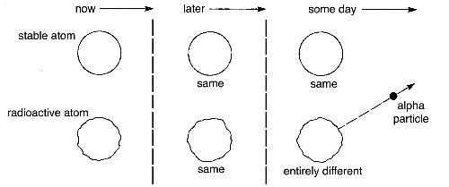
Radon gas is itself unstable and radioactive. Each of its atoms suddenly, at an unpredictable moment, hurls out an alpha particle. The remainder is a new atom, very unstable, which is called polonium, the “daughter” of radon and the “granddaughter” of radium. The series continues through several more radioactive elements and stops at a stable form of lead. It does not begin with radium: it begins with uranium several stages earlier. Radioactive uranium (Z=92) has turned into lead (Z=82).
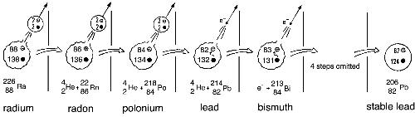
Making unstable atoms
A century ago, radioactivity was a peculiarity of a few, mostly heavy, elements: the last few at the end of the Periodic Table. Nowadays, scientists can bombard samples of lighter elements with high-speed, high-energy protons or neutrons, provided directly or indirectly by an accelerator. They can make unstable isotopes of every element in the periodic table. This has opened up the field of nuclear chemistry. Radioactive isotopes behave chemically like their stable isotopes and can be mixed with them. Their progress as radioactive tags can be traced, like luggage labels, following the progress of a “labelled” isotope through the human body or an industrial process.
Half-lives
All of the unstable members of these strange families have a constant, reliable characteristic: the atoms show no signs of aging, or growing weaker, however long they last. Each radioactive element has a constant chance of breaking up in each succeeding second. This is described by a useful length of time: the half-life of the radioactive element. For each individual atom the betting is 50:50 for and against its breaking up at any time during one half-life from a particular moment. The break-up seems to be controlled by pure chance. That chance does not change and make the break-up more likely for atoms that need to survive longer.
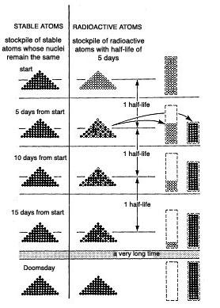
For radium the half-life is 1650 years. Start with 1000 mg of radium now and 1650 years later you will have only 500 mg left. After a further 1650 years only 250 mg will be left, and so on. For radium’s “daughter”, radon -222, the half-life is 3.8 days. In less than four days half of the radon gas will have disappeared. You will find helium gas there instead, with the solid products.
The instability appears to be something inherent in the nuclear structure. Nowadays, taking a wave view of the behaviour of nuclear particles, you can picture a stationary wave pattern defining the life of an alpha particle inside the nucleus. However, the wave is not completely confined – it leaks through the potential barrier round the nucleus and runs on as a faint wave outside. The wave is interpreted as describing probabilities of locations; it is not a mechanical wave carrying energy and momentum.
While the alpha particle is expected to be inside the nucleus, there is a chance of finding it one day outside, despite what would seem an insurmountable potential wall. That chance of the alpha particle being outside, being emitted, is definite and constant – a part of the defining wave property – as long as the nucleus lasts. It suggests that high-energy alpha particles go with a short half-life of the parent nucleus.

